Clinical Information Pack
Clinical Professor

Post title: | Associate Professor/Professor of Clinical Genetics & Genomics
Schools: | Human Development and Health
Faculty: | Faculty of Medicine (FoM)
Career Pathway: | Clinical | Level: | Clinical Consultant (MC51-MC71)
Salary | £93,666 | To | £112,356  (latest salary scale - April 2023)
Total Number of PA’s | 10 PAs
Associated NHS bodies | University Hospital Southampton NHS Foundation Trust (UHS)
Clinical category: | Balanced portfolio
Posts responsible to: | Head of School
Posts responsible for: | Research Staff and Postgraduate Research Students as appropriate

Particulars of Appointment

The Faculty of Medicine and University Hospital Southampton NHS Foundation Trust (UHS) wish to appoint an Associate Professor/Professor of Clinical Genetics & Genomics. This post will function within the Human Genetics & Genomic Medicine Group - part of the School of Human Development & Health of the Faculty of Medicine on the University Hospital Southampton campus. The post-holder will:

- Lead initiatives to drive research and education in Medical Genomics

- Ensure Wessex Medical Genomics active engagement in national and international initiatives

- Conceive, drive and lead research funding applications (to appropriate research council/ industry/NIHR/charities), to further discovery science and translational research in medical genomics

- Publish peer-reviewed papers in high impact journals and present these studies at scientific conferences and other professional forums

- Contribute to leadership, management, and delivery of education at UG (BM; genetics) and PG (PGT/PhD) levels including MSc Genomics

- Maintain a leadership role in shaping delivery of Medical Genomic education and research in line with the NHS Genomics Strategy and the NHS England plan to Accelerate Genomic Medicine in the NHS, the Genomic commitments of the NHS Long Term Plan and the UK Life Science Vision

- Make contributions to enterprise through research-related activities (e.g., industry/NIHR/research council/charity funded research including PhD students) and education-related activities (e.g., CPD in Genomics).

The University of Southampton

The University of Southampton is a leading research-intensive University, a member of the Russell Group and one of the top 100 universities worldwide. We deliver an excellent educational experience, world-leading research and we are known for successfully commercialising that research through enterprise.

This is an exciting time to join the University of Southampton. We have an aspirational University Strategy (see www.southampton.ac.uk/strategy), setting out our ambitions over the next five years. The strategy involves achieving a top 10 place in the UK for research, which we will achieve by investing in the highest quality staff and facilities. We are also transforming the education offer available to undergraduate and postgraduate students across the University, providing greater flexibility and modular courses, with a strong international focus.

The Faculty of Medicine

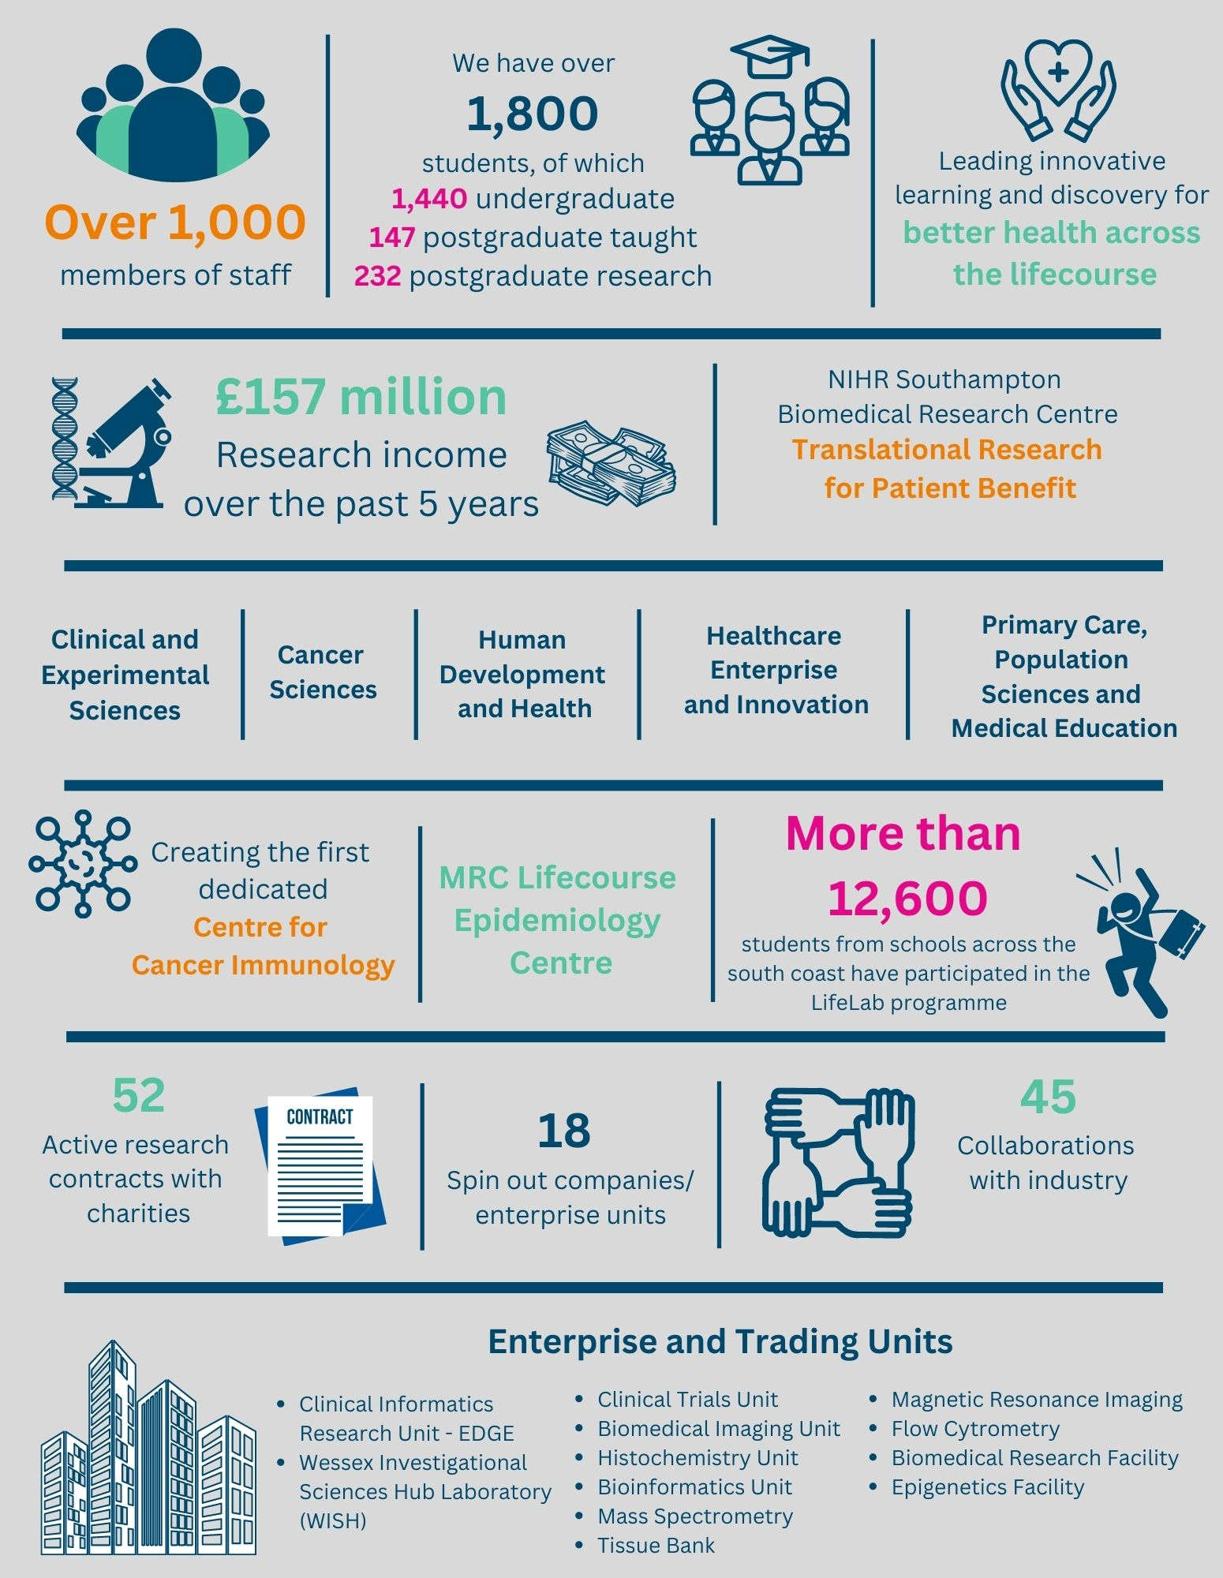

The creation of the Faculty of Medicine (FoM) has enabled us to build upon strong foundations of basic research and clinical translation. Working with colleagues across the University and in the local NHS we have strengthened our position as a renowned centre for translational research, leading innovative learning and discovery for better health across the life-course. In this context, we are looking to appoint an outstanding senior academic to develop and lead a major programme of funded clinical research in the field of genetics and genomics.
Key to the success of the Faculty of Medicine is the delivery of high-quality education for undergraduate and postgraduate students, building on our partnership in biomedical research with University Hospital Southampton NHS Foundation Trust and fostering new collaborations with the physical sciences, including chemistry, engineering, and computing. The post-holder will play a key role in these developments.

The Faculty celebrated its 40th anniversary in 2016. In 1971 FoM consisted of 40 students. FoM is now reputed for its excellence in research, innovative clinical teaching and is a vibrant pillar of the South of England community.

The Student Experience

We offer a range of undergraduate programmes: the BM4 programme, a graduate-entry four-year programme which accepts 40 students per year; and the BM5and BMedSc programme which accepts 200 students per year including approximately 30 students from a BM6 programme aimed at widening access to a medical career. Science teaching in the first three years of the BM programmes is delivered in the South Block of Southampton General Hospital as well as the Life Sciences Building on Highfield Campus. Clinical teaching takes place at Southampton General Hospital and the adjoining Princess Anne Hospital, the Royal South Hants Hospital, and in NHS Trusts and General Practices throughout Hampshire, Dorset, West Sussex and Salisbury.

The BM5 programme has a number of distinctive features. These include the integrated nature of teaching where the scientific disciplines are taught together in a clinical context using a systems-based approach and the BMedSc programme, an eight-month supervised research project undertaken in Year 4. There is also the opportunity, for selected students, to undertake an integrated, intercalated Masters in Medical Science (MMedSc). The BM4 programme also has a number of key features. These include clinical topics in the first two years where students meet on a regular basis in Graduate Groups and learning with BM5 students in the third and fourth years on all clinical attachments. All students take the same intermediate and final examinations. All programmes have substantial clinical experience in the first two years, student selected components, dispersed final year attachments, work shadowing prior to commencing a Foundation post and inter-professional learning.

In addition to the undergraduate BM programmes the School provides two Masters Degree programmes in Public Health and Allergy.

Research and Enterprise

The Faculty of Medicine has a clear research strategy to investigate the biomedical basis of common human diseases and to translate this into clinical practice. All research undertaken within the faculty has clear evidence of international excellence and is delivered through appropriate Faculty Schools.

The Faculty of Medicine Enterprise Strategy is fully aligned to the University Enterprise Strategy to provide a step change to its enterprise and innovation culture, delivering global outreach, community engagement, innovative healthcare, and policy. We work with all stakeholders from industry and pharma to health providers and the community.

Equality, Diversity and Inclusivity

We are committed to positively advancing equality of opportunity. We participate in a number of equality initiatives which celebrate good employment practice for the advancement of diversity, equality and inclusivity. These include the Stonewall Workplace Equality Index, the Race Equality Charter and Athena Swan, (for which we are currently silver award holders). We also have a number of staff equality committees who champion the advancement of equalities for diverse groups.

Southampton Behaviours

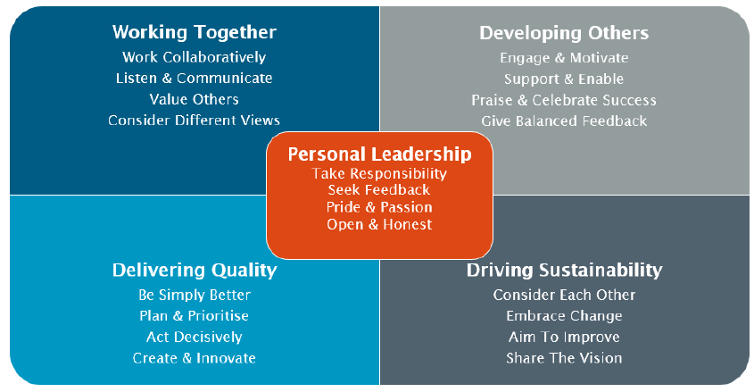

School Information

Human Development and Health

The School of Human Development and Health comprises over 250 scientists, clinicians, research students and associated technical and support staff with a research budget in excess of £6m/annum, under the leadership of Professor Philip Calder.

Key research themes within the School are Human Genetics and Genomic Medicine; Epigenetics; Bone and Joint and Regenerative Medicine; Developmental Physiology and Medicine; Nutrition, Endocrinology and Metabolism; and Global Health. The School also hosts the MRC Lifecourse Epidemiology Centre and is closely linked with the NIHR Southampton Biomedical Research Centre, leading its lifecourse nutrition theme, and with the Institute for Life Sciences.

Human Genetics & Genomic Medicine (HGGM), University of Southampton

Research within HGGM covers population statistical genetics and method development, through fundamental science (to understand how and why variation in the human genome and transcriptome alter health risks and outcomes) to translational research - where our findings feed back into the clinic to inform precision therapies.

While some of our research projects focus on specific disease areas, we apply an array of contemporary techniques across a vast array of clinical areas. We regularly apply ‘Omics technologies to generate vast data and so are heavy users of the University's High Performance Computing infrastructure.

We maintain strong links with the Clinical Informatics Research Unit, NHS Secure Data Environments and activities embedded with the Southampton NIHR BRC's Data, Health and Society theme. In addition to short and long read DNA and RNA sequencing, we apply metabolomics, proteomics and microbiome analyses. For integration of longitudinal clinical data with layered ‘omics data, we collaborate frequently with research colleagues from Computer Science, Systems Biology and Mathematics to model disease. In the wet laboratories, we use cell and 3-D models to elucidate critical function.

Much of our research benefits from particularly strong ties with clinical colleagues at University Hospital Southampton especially Clinical Genetics, Paediatrics, Oncology and Wessex Genomics Laboratories (Southampton & Salisbury). Our staff perform key roles in the NHS Genomic Medicine Service and run projects within the Genomic England Research Environment.

We have direct involvement in the Research Directorship and transformation projects within the Central & South Genomic Medicine Service and = NHSE Genomics Networks of Excellence. Our staff are strongly represented as GeCIP and project leads within Genomics England.

University Hospital Southampton NHS Foundation Trust (UHS)

University Hospital Southampton NHS Foundation Trust provides services to some 1.9 million people living in Southampton and south Hampshire, plus specialist services such as neurosciences, cardiac services and paediatric subspecialities to more than 3.7 million people in central southern England and the Channel Islands.
The Trust is also a major centre for teaching and research in association with the University of Southampton and partners including the Medical Research Council and Wellcome Trust.
UHS gained Foundation Trust status on 1 October 2011.
Every year 11,500 UHS staff:
- treat around 150,000 inpatients and day patients, including about 50,000 emergency admissions
- see over 624,000 people at outpatient appointments; and
- deal with around 135,000 cases in there emergency department.
Providing these services costs £1.9 million a day.

UHS Wessex Clinical Genetics Service

The Wessex Clinical Genetics Service (WCGS) is a Regional Service based at the Princess Anne Hospital, part of University Hospitals Southampton (UHS) NHS Trust. WCGS covers a population of ~3 million people across Hampshire, Dorset, South Wiltshire and the Isle of Wight. It is integrated with the Wessex Regional Genetics Laboratory in Salisbury and Southampton, and the Central and South Genomic Laboratory Hub in Birmingham. The Central and South NHS GMS Alliance includes the Wessex, Oxford and Birmingham regions and WCGS has representation on their operational board, as well as that of the C and S GLH. WCGS has close links with the University of Southampton Medical School.

Referrals to the Service
Referrals are accepted from any medical practitioner as well as from nurses, and other health professionals. Referral letters are co-ordinated in Southampton. Approximately 4800 referrals are received each year.

The criterion for referral is that a family requires assessment and information about a specific disorder occurring and the options available to deal with that risk. It may involve the diagnosis of rare genetic syndromes or information regarding prognosis for rare genetic disorders. Referrals need not be confined to high-risk families or established genetic disorders; families who are uncertain of their risks can be assessed. Adult and paediatric disorders are dealt with. 40% of referrals involve cancer, or a family history of cancer. The department hosts the familial hypercholesterolemia service for the region and is involved in developing the FH service nationally (the C and S GMSA is leading on this for NHS-E). Candidates with particular clinical and research interests are welcomed as these could be developed to complement the portfolio of the existing team.

Families are referred from Wessex (Southampton, Portsmouth, Salisbury, Basingstoke, Winchester, Isle of Wight and Dorset) and the Channel Islands. Regular outpatient clinics in general Clinical Genetics and Cancer Genetics have been set up across the region. Clinics are also carried out by telephone or video.

Job Description and Person Specification

Job purpose
To undertake research, education, and management activities (0.4fte); and to undertake clinical duties as a Consultant Clinical Geneticist (0.6fte). Additional clinical time may be conducted out of core working hours, to be agreed within the job plan.

Key Research accountabilities |  | % Time
 | To develop and carry out an area of personal research in Human Genetics and Genomics, further developing this as an area of excellence for the University.  To disseminate findings in peer-reviewed journals, present results at conferences or exhibit work at appropriate events.  To lead the writing of bids to attract research funding, and to contribute to those of colleagues where appropriate.  Carry out administrative tasks associated with specified research funding, for example risk assessment of research activities, ethics and data governance, organisation of project meetings and documentation. Implementation of procedures required to ensure accurate and timely formal reporting and financial control. | 30%
 | Key Education accountabilities
 | Directly supervise students and post-doctoral researchers, including PhD students, providing advice on study skills, and helping with learning problems. Identify the learning needs of students and define learning objectives. Set and mark coursework and exams, providing constructive feedback to students.  As a member of a teaching team within an established programme of study, support the teaching objectives of the School/Department by delivering teaching to students at undergraduate and/or postgraduate level, through allocated lectures, tutorials, practicals and seminars.  Develop own teaching materials, methods, and approaches, with guidance. Obtain and analyse feedback on own teaching design and delivery to facilitate this.  Continually update own knowledge and understanding of subject area, incorporating knowledge of advances into own teaching contributions. | 5%

 | Key Management, Leadership and Engagement accountabilities
 | Contribute to the efficient management and administration of the School/Department by performing personal administrative duties as allocated by the Head, e.g., library representative, year tutor, exchange-programme coordinator, etc. | 5%
Key Clinical accountabilities |  | % Time
UHS has 4 Clinical Divisions, each with a number of Care Groups. Clinical Genetics is part of the Specialist Medicine Care Group, within Division B.  All Consultants in each Care Group are managerially accountable to the Divisional Clinical Director, who has overall responsibility for the services provided.  All consultants come within the Division and are expected to participate in the medical contribution to management and the clinical governance agenda.  On-call Arrangements  There is no formal out of hours on call in Clinical Genetics. Depending on the specialist areas of interest of the post holder, they may take part in the within hours on call service for urgent inpatient referrals. |  | 60%

Internal and External Relationships
Direct responsibility to HGGM leads and head of school.
Additional reporting and liaison responsibilities to NHS Genomic Medicine Service.
Collaborators/colleagues in other work areas and institutions.

Staff Benefits
Working at the University of Southampton gives you access to a wide range of benefits in addition to our competitive rates of pay. Our core benefits include pension scheme membership (or continued ability to opt into the NHS pension scheme); a generous annual leave allowance (supplemented by University closure days and public holidays) and excellent family leave arrangements (including maternity, paternity, adoption and parental leave).

- Faculty Mentoring Scheme;
- Ability to remain in NHS pension scheme, subject to qualifying criteria;
- Discounted Sport and Wellbeing membership;
- Access to private dental and/or healthcare insurance;
- Cycle to work scheme
- Tax-Free childcare

Person Specification

Criteria | Essential | Desirable | How to be assessed
Qualifications, knowledge and experience | Medical degree  Full GMC registration  PhD or MD in area relevant to Medical Genomics  MRCP or MRCPCH  CCT in Clinical Genetics or equivalent training and experience (eligible for CESR)  Evidence of commitment to a clinical academic career  Evidence of ability to drive hypothesis-led and discovery-research through successful leadership of grant applications and research programme delivery through to publication.  Experience of undergraduate/postgraduate medical teaching |  | CV
Planning and organising | Ability to organise own research activities to deadlines and standards |  | CV
Problem solving and initiative | Ability to develop understanding of complex problems and apply in-depth knowledge to address them |  | CV
Management and teamwork | Experience of successful leadership and management of multi-professional teams  Effectively participate in and lead teams, understanding strengths and weaknesses of others |  | CV
Communicating and influencing | Communicating new and complex information effectively, both verbally and in writing, engaging the interest and enthusiasm of the target audience (scientists, NHS stakeholders including NHS GMS, public and patient groups)  Ability to present research results at group meetings and conferences  Track record of original publications in leading peer-reviewed journals  Work proactively with colleagues in other work areas/institutions, contributing specialist knowledge to achieve outcomes  National/ international research award(s) |  | CV
Other skills and behaviours | Positive attitude to colleagues and students. |  | CV
Special requirements | Able to attend national and international conferences to present research results  Experience of presenting at national and international conferences |  | CV

JOB HAZARD ANALYSIS

Is this an office-based post?
☐ Yes | If this post is an office-based job with routine office hazards (eg: use of VDU), no further information needs to be supplied. Do not complete the section below.
☒ No | If this post is not office-based or has some hazards other than routine office (eg: more than use of VDU) please complete the analysis below.  Hiring managers are asked to complete this section as accurately as possible to ensure the safety of the post-holder.

## - HR will send a full PEHQ to all applicants for this position. Please note, if full health clearance is required for a role, this will apply to all individuals, including existing members of staff.

ENVIRONMENTAL EXPOSURES | Occasionally  (<30% of time) | Frequently  (30-60% of time) | Constantly  (> 60% of time)
Outside work
Extremes of temperature (eg: fridge/ furnace)
## Potential for exposure to body fluids
## Noise (greater than 80 dba - 8 hrs twa)
## Exposure to hazardous substances (eg: solvents, liquids, dust, fumes, biohazards). Specify below:
Frequent hand washing
Ionising radiation
EQUIPMENT/TOOLS/MACHINES USED
## Food handling
## Driving university vehicles(eg: car/van/LGV/PCV)
## Use of latex gloves (prohibited unless specific clinical necessity)
## Vibrating tools (eg: strimmers, hammer drill, lawnmowers)
PHYSICAL ABILITIES
Load manual handling
Repetitive crouching/kneeling/stooping
Repetitive pulling/pushing
Repetitive lifting
Standing for prolonged periods
Repetitive climbing (ie: steps, stools, ladders, stairs)
Fine motor grips (eg: pipetting)
Gross motor grips
Repetitive reaching below shoulder height
Repetitive reaching at shoulder height
Repetitive reaching above shoulder height
PSYCHOSOCIAL ISSUES
Face to face contact with public
Lone working
## Shift work/night work/on call duties

